Learning from Data Homework 5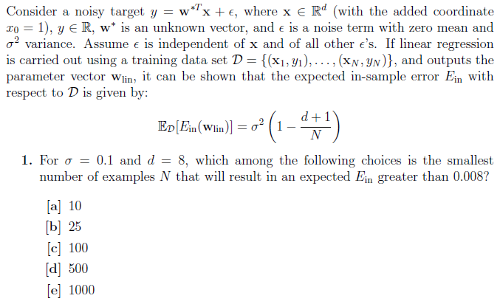

Correction: C. Program (num1.java in hw5Programs) worked completely fine (gave me C), but I didn’t understand why $N$ increasing would increase the error so I picked A. now I see that this is $E_{in}$, which would increase with $N$ because the model loses its ability to memorize the data points as $N$ increases. 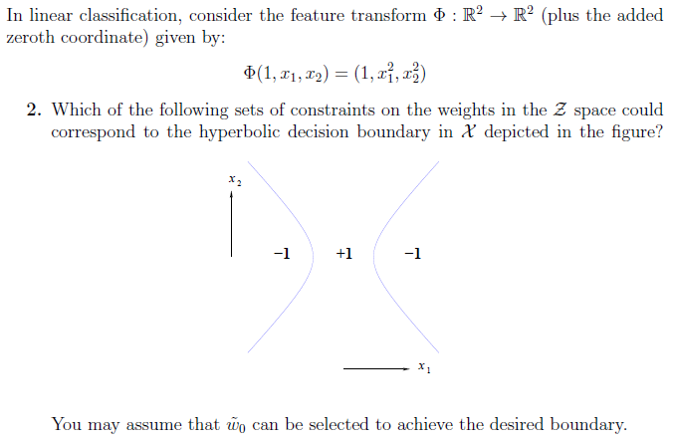

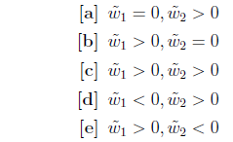

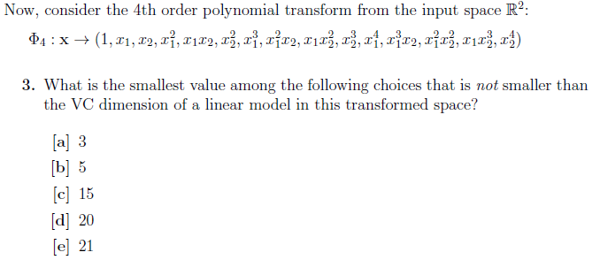

If we recall from lecture, $d_{VC}=d+1$ of a perceptron with $d$ dimensions. $d=15$, so $d_{VC}=16$.

Correction: C. $d$ does not include $x_{0}$ (the intercept dimension of all 1’s put in for mathematical convenience). Hence, $d_{VC}=14+1=15$. 15 is not smaller than 15.

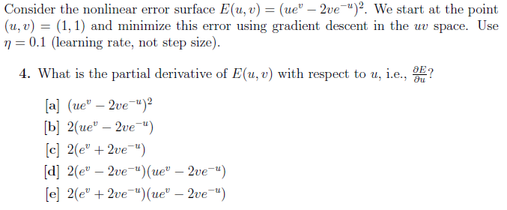

$$\frac{∂E}{∂u}=\frac{∂{\left(ue^{v}-2ve^{-u}\right)}^{2}}{∂u}=2(ue^{v}-2ve^{-u})(e^{v}+2ve^{-u})$$

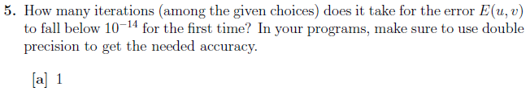

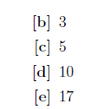

I also need to derive $\frac{∂E}{∂v}:$

$$\frac{∂E}{∂v}=\frac{∂{\left(ue^{v}-2ve^{-u}\right)}^{2}}{∂v}=2(ue^{v}-2ve^{-u})(ue^{v}-2e^{-u})$$

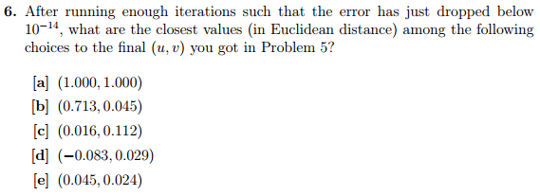

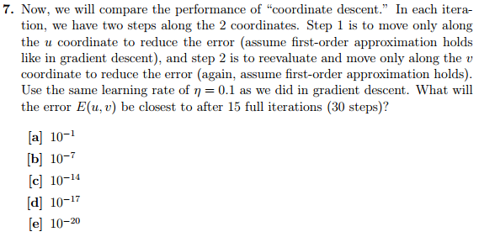

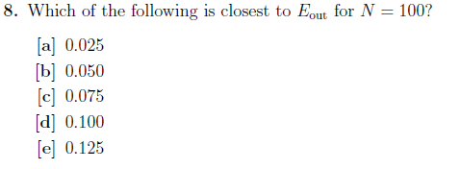

Correction: D, I mistakenly set $η=0.1$ instead of $0.01$.

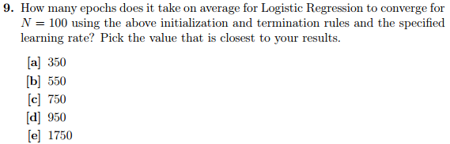

Implemented with LogisticReg.java within hw5Programs

Correction: A, I mistakenly set $η=0.1$ instead of $0.01$

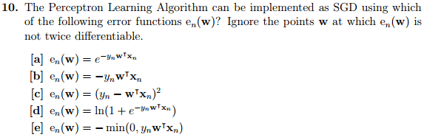

Correction: E. I didn’t properly think about the problem: thinking about the weights $w$ as a vector, it doesn’t makes sense that one would add $y_{n}w^{T}x_{n}$ to them if $y_{n}$ and $w^{T}x_{n}$ have the same sign (signifying correctly predicted). You would only want adding if $y_{n}$ is positive but $w^{T}x_{n}$ is negative (to bring $w$ closer to $x_{n}$ so that $x_{n}$ has a positive component upon it). Only E exhibits this (while using the same error function as PLA).

Homework 5 Solutions

7/10 (not taking off more than 1 point for same mistake)

Incorrect Problems:

* #1, forgot $N_{1}>N_{2}→E_{in}^{1}>E_{in}^{2}$
* #3, forgot $d$ in Abu-Mostafa’s notation doesn’t include $x_{0}$ (the intercept dimension)
* #8, set $η=0.1$ instead of $0.01$
* #9, set $η=0.1$ instead of $0.01$
* #10, didn’t think properly about problem

